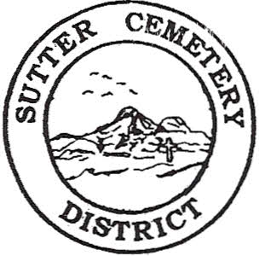
Wednesday

May 14, 2025

8:30 A.M.

1. Adoption of the Agenda. Motion needed.

2. Public Comment: This is the time for the public to speak on any subject. The Board will allow 5 minutes per person per subject.

3. Approval of the Minutes of the April 09, 2025 Regular Board Meeting. Motion needed.

4. Approval of the Accounts Payable and the Financial Statement (information to be provided at meeting). Motion needed.

OLD BUSINESS:

1. Farmland Development Committee progress report – Mr. Perry & Mr. Munger.

2. Memorial Day Services Committee Report – Mrs. Brown & Mrs. Eggleston.

NEW BUSINESS:

1. Vandel “Bud” Myers appointed by Sutter County Board of Supervisors as trustee on the Sutter Cemetery District’s Board through March 05, 2026 to complete Mr. William D. Cochran’s term. –Office Supervisor Hanna.

2. Discussion and possible approval of changing the Sutter Cemetery District Administration Office Building hours to Monday through Friday, 8:00 a.m. to 4:00 p.m. –Office Supervisor Hanna. Motion Needed.

3. Discussion and possible approval of revising Article XVII-Personnel, Salary, and Benefits Policy, Section 2. Salaries & Wages , #7 & #8 to combine the positions to Receptionist/Office Clerk and revise pay scale (information included in packet). –Office Supervisor Hanna. Motion Needed.

4. Flag Retirement Ceremony presented by American Legion Post 705 is scheduled for Saturday, June 14th, 2025 at 9:00 a.m. at the Sutter Cemetery – Manager Dollins.

5. Discussion and review of the tentative 2025-2026 Budget (information to be provided at meeting). – Office Supervisor Hanna.

6. Groundskeeper, Ronald Sheffield, gave notice of resignation effective 05/15/2025 –Manager Dollins..

7. Manager’s Report –Manager Dollins
- Update on grounds.

OTHER BUSINESS:

1. Open Comment: This is time for the Board of Trustees and staff to make comments.

