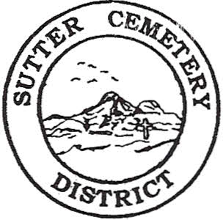
Wednesday

July 09, 2025

8:30 A.M.

1. Adoption of the Agenda. Motion needed.

2. Public Comment: This is the time for the public to speak on any subject. The Board will allow 5 minutes per person per subject.

3. Approval of the Minutes of the June 13, 2025 Regular Board Meeting. Motion needed.

4. Approval of the Accounts Payable and the Financial Statement. Motion needed.

OLD BUSINESS:

1. Farmland Development Committee progress report – Mr. Perry & Mr. Munger.

2. Flag Retirement Ceremony presented by American Legion Post 705 is scheduled for Saturday, June 14th, 2025 at 9:00 a.m. at the Sutter Cemetery – Manager Dollins

NEW BUSINESS:

1. Discussion and possible approval of the revised 2024-2025 Budgets and Resolution #25-7. –Office Supervisor Hanna. Motion needed.

2. Discussion and possible approval of Resolution #25-8 to transfer $175,000 from the General Fund to the Payroll Account for the 25-26 1st Qtr. payroll expenses. –Office Supervisor Hanna. Motion needed.

3. Yearly recommendation letter for the Board to accept the evaluation of Groundskeeper Victor Ayala Garnica –Manager Dollins. Motion needed.

4. Manager’s Report –Manager Dollins
- Update on grounds.

OTHER BUSINESS:

1. Open Comment: This is time for the Board of Trustees and staff to make comments.

