**Yuba Sutter**

**Wreaths Across America**

**December 14, 2024 9:00 AM**

**$17/Wreath**

**For every 2 wreaths purchased through Yuba Sutter Veterans Stand Down,**

**the cemetery will receive a 3rd wreath at no cost.**

***To ensure your wreaths makes it to your chosen location, please include the cemetery name on your check***

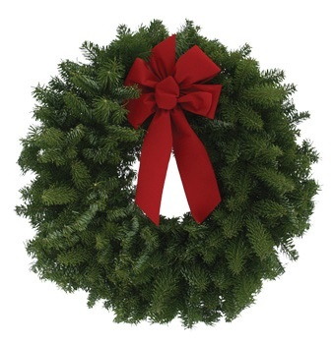

**Participating Cemeteries:**

* **Sutter Cemetery**
* **Meridian Cemetery**
* **Yuba City Cemetery**

Deadline to order is Nov 28

**Sponsor online @ WreathsAcrossAmerica.org/ca0179**

**Or mail your check made out to:**

**Wreaths Across America**

**C/O Yuba Sutter Veterans Stand Down**

**PO Box 1775/ Marysville CA 95901**

**For more info contact**

**Tom Walther at 530-218-3847 or**

**Cindy Languell at 530-301-3074**