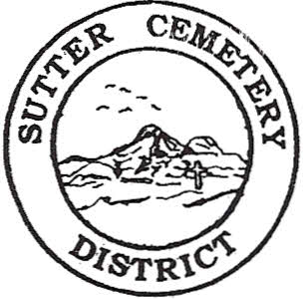
Wednesday

August 21, 2024

8:30 A.M.

1. Adoption of the Agenda. Motion needed.

2. Public Comment: This is the time for the public to speak on any subject. The Board will allow 5 minutes per person per subject.

3. Approval of the Minutes of the July 10, 2024 Regular Board Meeting. Motion needed.

4. Approval of the Accounts Payable and the Financial Statement. Motion needed.

OLD BUSINESS:

1. Farmland Development Committee progress report – Mr. Perry & Mr. Munger.

NEW BUSINESS:

1. Discussion and possible approval of Resolution #24-7 to accept the Debt Issuance Policies & Procedures to the Sutter Cemetery District Policies & Procedures. –Office Supervisor Hanna. Motion needed.

2. Discussion and possible approval of Resolution #24-8 to accept the contract agreement from Capital One Bank for the 10 year loan in the amount of $1,000,000 in order to fund the Sutter Cemetery Expansion Project. Best Best & Krieger Attorneys at Law Counsel, Brian Hughes, to speak on the subject. Motion needed.

3. Discussion and possible approval of Resolution #24-9 to accept the Revised Budget for fiscal year 2024-2025 to reflect the monies for the Sutter Cemetery Expansion Project. –Office Supervisor Hanna. Motion needed.

4. Groundskeeper Martin Eredia gave his resignation effective August 09, 2024 –Manager Dollins.

5. Discussion on the cost of living and the District’s employee pay rates – Office Supervisor Garcia.

6. Discussion on the possible name change of the Sutter Buttes to “Sacred Buttes” and its possible impact on the Sutter Cemetery District and the community. –Mr. Munger.

7. Manager’s Report –Manager Dollins
- Update on grounds.
- Pump repairs (pump by shop).

OTHER BUSINESS:

1. Open Comment: This is time for the Board of Trustees and staff to make comments.

