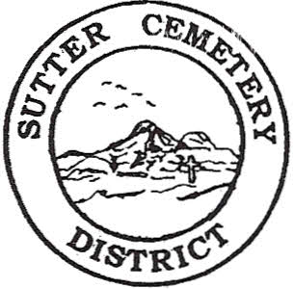
Friday

June 13, 2025

8:30 A.M.

1. Adoption of the Agenda. Motion needed.

2. Public Comment: This is the time for the public to speak on any subject. The Board will allow 5 minutes per person per subject.

3. Approval of the Minutes of the May 14, 2025 Regular Board Meeting. Motion needed.

4. Approval of the Accounts Payable and the Financial Statement (information to be provided at meeting). Motion needed.

OLD BUSINESS:

1. Farmland Development Committee progress report – Mr. Perry & Mr. Munger.

2. Memorial Day Services Committee Report – Mrs. Brown & Mrs. Eggleston.

3. Flag Retirement Ceremony presented by American Legion Post 705 is scheduled for Saturday, June 14th, 2025 at 9:00 a.m. at the Sutter Cemetery – Manager Dollins

NEW BUSINESS:

1. Discussion and review of the 2023-2024 audit and approval of the audit and Resolution #25-5. Norm Newell from Smith & Newell CPAs that prepares the audit, to attend the meeting. Copies of the audit provided at meeting. Motion needed.

2. Discussion and possible approval of proposal to audit the District’s financial statement by Smith & Newell CPAs for fiscal years ending June 30, 2025, 2026 and 2027 –Office Supervisor Hanna. Motion needed.

3. Discussion and possible approval of the final 2025-2026 Budget, Melba Silva Budget, Preneed Budget, and Meridian Budget as well as Resolution #25-6. –Office Supervisor Hanna. Motion Needed.

4. Discussion and possible approval of a price increase for burial fees to be effective July 01, 2025 –Office Supervisor Hanna. Motion needed.

5. Yearly recommendation letter for the Board to accept the evaluation of District Manager Darin Dollins –Mrs. Brown & Mrs. Eggleston. Motion needed.

6. Manager’s Report –Manager Dollins
- Update on grounds.

OTHER BUSINESS:

1. Open Comment: This is time for the Board of Trustees and staff to make comments.

