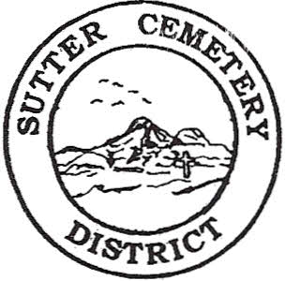
Wednesday

April 09, 2025

8:30 A.M.

1. Adoption of the Agenda. Motion needed.

2. Public Comment: This is the time for the public to speak on any subject. The Board will allow 5 minutes per person per subject.

3. Approval of the Minutes of the March 12, 2025 Regular Board Meeting. Motion needed.

4. Approval of the Accounts Payable and the Financial Statement. Motion needed.

OLD BUSINESS:

1. Farmland Development Committee progress report – Mr. Perry & Mr. Munger.

2. Memorial Day Services Committee Report – Mrs. Brown & Mrs. Eggleston.

3. Discussion on the financial delays at the Sutter County Auditor-Controller’s Office that significantly impact special districts –Office Supervisor Hanna.

NEW BUSINESS:

1. Yearly recommendation letter for the Board to accept the evaluation of Cole Jesse Younger and move Mr. Younger to Assistant Foreman Step 4 – Manager Dollins. Motion needed.

2. Manager’s Report –Manager Dollins
- Update on grounds.

OTHER BUSINESS:

1. Open Comment: This is time for the Board of Trustees and staff to make comments.

