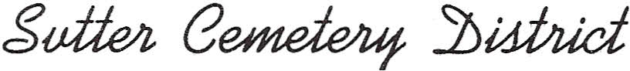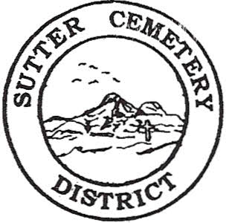

Trustees

# William D. Cochran

Chairman

Steve Perry

Jeanne Brown

Larry Munger

Susan Eggleston

7200 BUTTE AVENUE   
 SUTTER, CALIFORNIA 95982

Phone (530) 755-0346

Fax (530) 755-3398

December 06, 2024

MEMO

RE: Rescheduled Regular Board Meeting

The Sutter Cemetery District’s Regular Board Meeting for Wednesday, December 11, 2024 at 8:30 a.m. has been cancelled and **rescheduled for Monday, December 16, 2024 at 8:30** a.m. If you have any questions or concerns, you may contact the administration office at (530) 755-0346 during business hours, Monday through Friday, 8:00 a.m. to 4:30 p.m.