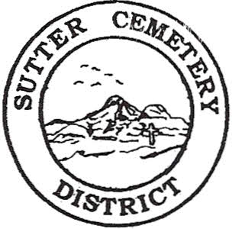
Wednesday

July 10, 2024

8:30 A.M.

1. Adoption of the Agenda. Motion needed.

2. Public Comment: This is the time for the public to speak on any subject. The Board will allow 5 minutes per person per subject.

3. Approval of the Minutes of the June 12, 2024 Regular Board Meeting. Motion needed.

4. Approval of the Accounts Payable and the Financial Statement. Motion needed.

OLD BUSINESS:

1. Farmland Development Committee progress report – Mr. Perry & Mr. Munger.

2. Discussion on financial aid and financial options for the farmland development project –Mr. Munger & Mr. Perry.

NEW BUSINESS:

1. Discussion and possible approval to accept the quote from CSDA Finance Corporation for a loan to finance the funds to develop the 7 acres of the farmland development project into cemetery use. Motion needed.

2. Discussion and possible approval of the revised 2023-2024 budgets and Resolution #24-6. –Office Supervisor Hanna. Motion needed.

3. Yearly recommendation letter for the Board to accept the evaluation of Groundskeeper Victor Ayala Garnica and to move Mr. Garnica to Groundskeeper Step 7 –Manager Dollins. Motion needed.

4. Manager’s Report –Manager Dollins
- Update on grounds.

OTHER BUSINESS:

1. Open Comment: This is time for the Board of Trustees and staff to make comments.

