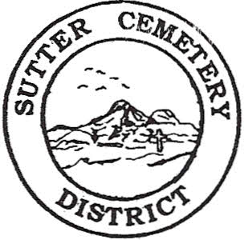
Wednesday

September 10, 2025

8:30 A.M.

1. Adoption of the Agenda. Motion needed.

2. Public Comment: This is the time for the public to speak on any subject. The Board will allow 5 minutes per person per subject.

3. Approval of the Minutes of the August 14, 2025 Regular Board Meeting. Motion needed.

4. Approval of the Accounts Payable and the Financial Statement. Motion needed.

OLD BUSINESS:

1. Farmland Development Committee progress report – Mr. Perry & Mr. Munger.

2. Discussion and possible approval of Resolution #25-8 to move the Sutter Cemetery District’s LAIF 6408 account from a separate LAIF account to a regular account with the Sutter County’s Pool within the Sutter County Treasurer Department-Office Supervisor Hanna. Motion needed.

NEW BUSINESS:

1. Golden State Risk Management Authority’s 19th Annual Training Conference, held October 9-10, 2025 at Rolling Hills Resort & Casino, in Corning, Ca (Information provided in packet) –Office Supervisor Garcia.

2. Discussion and possible approval of promoting Catarina Eaton from Extra Help Receptionist to Full Time Office Clerk/Receptionist Step 1 –Office Supervisor Hanna. Motion needed.

3. Discussion and possible approval of promoting Cristobal Ramirez Valencia from Extra Help Groundskeeper to Full Time Groundskeeper Step 1 –Manager Dollins. Motion needed.

4. Yearly recommendation letter to accept the evaluation of Office Supervisor Mickaela Garcia and move Mrs. Garcia to Office Supervisor Step 5 –Office Supervisor Hanna. Motion needed.

5. Yearly recommendation letter to accept and evaluation of Groundskeeper Jacob Johnson and move Mr. Johnson to Groundskeeper Step 6 –Manager Dollins. Motion needed.

6. Manager’s Report –Manager Dollins
- Update on grounds.
- Halloween Patrol.

OTHER BUSINESS:

1. Open Comment: This is time for the Board of Trustees and staff to make comments.

