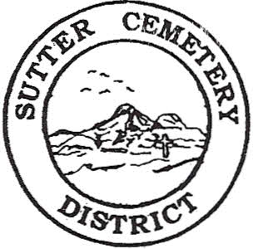
Wednesday

October 08, 2025

8:30 A.M.

1. Adoption of the Agenda. Motion needed.

2. Public Comment: This is the time for the public to speak on any subject. The Board will allow 5 minutes per person per subject.

3. Approval of the Minutes of the September 10, 2025 Regular Board Meeting. Motion needed.

4. Approval of the Accounts Payable and the Financial Statement. Motion needed.

OLD BUSINESS:

1. Farmland Development Committee progress report – Mr. Perry & Mr. Munger.

NEW BUSINESS:

1. Resolution #25-8 to transfer $175,000 from the General Fund to the Payroll Account for the 2nd Quarter 2025-2026 payroll expenses. –Office Supervisor Hanna. Motion needed.

2. Review and approval of the Sutter County Conflict of Interest Code. (Information provided in packet) -Office Supervisor Hanna. Motion needed.

3. Discussion to set a time and date for a special meeting to tour the District cemeteries and have the Employee Luncheon. –Manager Dollins

4. Yearly recommendation letter for the board to accept the evaluation of Cesar Valdez– Manager Dollins. Motion needed.

5. Manager’s Report –Manager Dollins
- Update on grounds.
- Pregnancy Loss Memorial Update.

OTHER BUSINESS:

1. Open Comment: This is time for the Board of Trustees and staff to make comments.

