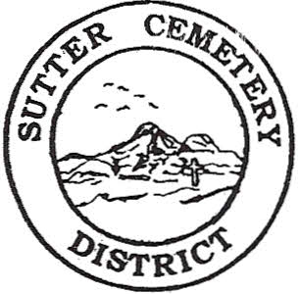
Monday

November 18, 2024

8:30 A.M.

1. Adoption of the Agenda. Motion needed.

2. Public Comment: This is the time for the public to speak on any subject. The Board will allow 5 minutes per person per subject.

3. Approval of the Minutes of the October 09, 2024 Regular Board Meeting. Motion needed.

4. Approval of the Minutes of the October 21, 2024 Special Board Meeting. Motion needed.

5. Approval of the Accounts Payable and the Financial Statement. Motion needed.

OLD BUSINESS:

1. Farmland Development Committee progress report – Mr. Perry & Mr. Munger.

NEW BUSINESS:

1. Discussion and possible approval of street names in the new development of Sutter Cemetery –Manager Dollins.

2. Yearly recommendation letter for the board to accept the evaluation of Anthony Salacup and move Mr. Salacup to Mechanic/Groundskeeper Step 7 – Manager Dollins. Motion needed.

3. Manager’s Report –Manager Dollins
- Update on grounds.

OTHER BUSINESS:

1. Open Comment: This is time for the Board of Trustees and staff to make comments.

