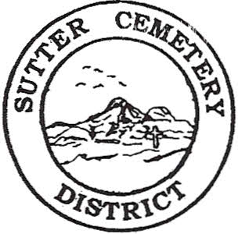
Wednesday

September 11, 2024

8:30 A.M.

1. Adoption of the Agenda. Motion needed.

2. Public Comment: This is the time for the public to speak on any subject. The Board will allow 5 minutes per person per subject.

3. Approval of the Minutes of the August 21, 2024 Regular Board Meeting. Motion needed.

4. Approval of the Accounts Payable and the Financial Statement. Motion needed.

OLD BUSINESS:

1. Farmland Development Committee progress report – Mr. Perry & Mr. Munger.

NEW BUSINESS:

1. Discussion on updating and revising the Sutter Cemetery District’s Policies & Procedures to reflect the current laws –Office Supervisor Hanna

2. Discussion and possible approval of promoting Receptionist Hannah Smith to Full Time Receptionist Step 5 –Office Supervisor Hanna. Motion needed.

3. Golden State Risk Management Authority Annual Training Conference at the Rolling Hills Resort in Corning, CA on October 24-25, 2024. Must register by September 30, 2024 (seating limited). Information enclosed –Office Supervisor Hanna.

4. Yearly recommendation letter to accept the evaluation of Office Supervisor Mickaela Garcia and move Mrs. Garcia to Office Supervisor Step 4. –District Manager Dollins. Motion needed.

5. Yearly recommendation letter to accept the evaluation of Groundskeeper Jacob Johnson –District Manager Dollins. Motion needed.

6. Manager’s Report –Manager Dollins
- Update on grounds.
- Halloween Patrol.
- Fencing in Yuba City Cemetery.

OTHER BUSINESS:

1. Open Comment: This is time for the Board of Trustees and staff to make comments.

