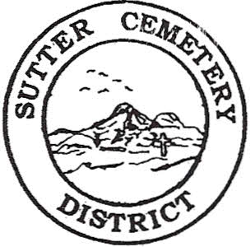
Wednesday

October 09, 2024

8:30 A.M.

1. Adoption of the Agenda. Motion needed.

2. Public Comment: This is the time for the public to speak on any subject. The Board will allow 5 minutes per person per subject.

3. Approval of the Minutes of the September 11, 2024 Regular Board Meeting. Motion needed.

4. Approval of the Minutes of the September 27, 2024 Special Board Meeting. Motion needed.

5. Approval of the Accounts Payable and the Financial Statement. Motion needed.

OLD BUSINESS:

1. Farmland Development Committee progress report – Mr. Perry & Mr. Munger.

NEW BUSINESS:

1. Discussion on letter that was received from the Bautista Family in regards to placement and removal of items on graves. –Manager Dollins.

2. Discussion on possibly moving the December 2024 Regular Board Meeting to Monday, December 16, 2024 at 8:30 a.m. –Mr. Cochran.

3. Yearly recommendation letter for the board to accept the evaluation of Cesar Valdez and move Mr. Valdez to Foreman Step 5 – Manager Dollins. Motion needed.

4. Manager’s Report –Manager Dollins
- Update on grounds.
- Halloween Patrol.
- Fencing in Yuba City Cemetery.

OTHER BUSINESS:

1. Open Comment: This is time for the Board of Trustees and staff to make comments.

